Disability Resources

ACCESSIBILITY, ACCOMMODATIONS, AND ASSISTIVE TECHNOLOGY

Massachusetts

Institute for Community Inclusion – www.communityinclusion.org
Technical assistance, training, and research organization, based at UMass Boston and affiliated with Boston Children’s Hospital, focused on inclusion of individuals with disabilities in education, employment, and community life.

DESE Adult and Learning Community Services
- Disability information- www.doe.mass.edu/acls/disability/default.html
- ADA standards - www.doe.mass.edu/acls/ada/standards.html

Massachusetts Assistive Technology in Consumer's Hands (MATCH) - www.massmatch.org
State’s federally funded, assistive technology program available to assist in identifying technology.

National

National Center for Educational Outcomes - https://nceo.info/
National technical assistance center on inclusion of students with disabilities in comprehensive assessment systems. Has extensive resources on test accommodations and related topics.

Job Accommodation Network (JAN) - https://askjan.org
Free information and consultation service on accommodations and related information. Although focused on job accommodations, has extensive information on accommodations and supports that can benefit students with disabilities.

ABLEDATA - https://abledata.acl.gov
Provides information on assistive technology and rehabilitation equipment, including a database of 25,000 products and devices.

WebAim: Web Accessibility in Mind - https://webaim.org
Comprehensive resource on web accessibility.

W3C Web Accessibility Initiative - www.w3.org/WAI
World Wide Web Consortium website with extensive resources on web accessibility.
- WCAG 2.1 – Web Content Accessibility Guidelines 2.1 - www.w3.org/TR/WCAG21
Accessibility guidelines from the World Wide Web Consortium.

ADA and Other Legal Requirements

Massachusetts

Massachusetts Office on Disability - www.mass.gov/mod
State advocacy agency that serves people with disabilities.

Massachusetts Commission Against Discrimination - www.mass.gov/mcad
State’s chief civil rights agency. Handles charges of discrimination and also provides a variety of training to the public.

New England ADA Technical Assistance Center - www.newenglandada.org
Provides comprehensive information, training, and technical assistance on the Americans with Disabilities Act and accessible information technology.

National

U.S. Department of Justice ADA Technical Assistance Center - www.ada.gov
Extensive materials and resources on the Americans with Disabilities Act. In addition, ADA specialists are available to obtain answers to general and technical questions about the ADA, and to order technical assistance materials.
- Guidance on testing accommodations - www.ada.gov/regs2014/testing_accommodations.html

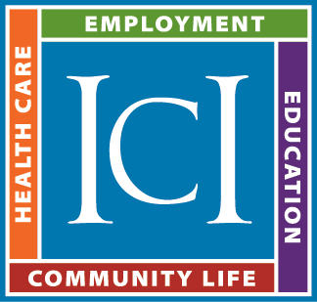
Prepared by David Hoff
Institute for Community Inclusion - University of Massachusetts Boston
Office: 617-287-4308 - Cell: 617-480-9230
Email: david.hoff@umb.edu
www.communityinclusion.org

